0.8 Buses
Now we're connecting the CPU to the rest of the MCU.
You've already learned that registers such as GPIOA, RCC, USART, etc. have memory addresses. The missing question is:
How does the CPU actually communicate with those memory locations and peripherals?
The answer is the bus system.

0.8.1 First, the basic idea
Think of the bus as the communication pathway inside the MCU.
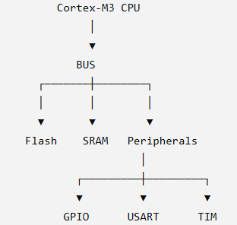
The CPU doesn't have a separate physical wire directly to every peripheral.
Instead, the MCU has an internal interconnect/bus architecture that allows the CPU and other components to communicate with memory and peripherals.

0.8.2 Why do we need a bus?
Imagine an MCU with:
CPU
Flash
SRAM
GPIO
UART
SPI
I2C
Timer
ADC
If we physically connected the CPU independently to everything, the architecture would become complicated very quickly.
Instead:

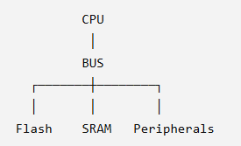
The bus provides a structured way to move:
- addresses
- data
- control information
between the CPU and different parts of the MCU.

0.8.3 Address + Data + Control
When the CPU wants to access something, conceptually there are three important pieces:
CPU
│
├── Address
├── Data
└── Control
│
▼
BUS
Address
Where do I want to access?
For example:
0x4001080C
which you've already encountered as the GPIOA ODR address for STM32F103.
Data
What value am I reading or writing?
For example:
0x00000020
Control
What kind of operation is this?
For example:
READ
WRITE
So conceptually:
WRITE:

CPU
│
├── Address = GPIOA_ODR
├── Data = 0x20
└── Write
│
▼
BUS
│
▼
GPIOA ODR
That's the hardware-level idea behind something as simple as:
GPIOA_ODR |= (1 << 5);

0.8.4 Now AHB and APB
For STM32F1, you'll encounter these names:
AHB
APB1
APB2
Don't memorize the peripheral lists yet. First understand the hierarchy.
A simplified picture is:
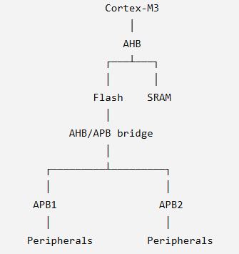
The exact STM32F103 bus matrix/interconnect has more detail than this simplified diagram. For Level 0, we're interested in understanding the architectural roles rather than memorizing every internal connection.

0.8.5 What does AHB mean?
AHB = Advanced High-performance Bus
It is part of ARM's AMBA bus architecture.
At our level:
AHB is the higher-performance bus layer connecting the Cortex-M system to important memory/system components and providing paths toward peripheral buses.
Think:
CPU
│
▼
AHB
│
├── Flash
├── SRAM
└── peripheral bridge

0.8.6 What does APB mean?
APB = Advanced Peripheral Bus
APB is designed for peripherals.
The STM32F1 has:
APB1
APB2
These provide clock and communication domains for groups of peripherals.
A simplified picture:
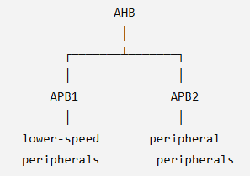
The exact clock frequencies and peripheral assignments depend on the STM32 family and configuration, which we'll study properly in 0.9 Clock & Reset.

0.8.7 Why are there APB1 and APB2?
Because STM32 doesn't simply put every peripheral on one giant peripheral bus.
It separates peripheral groups into different domains.
For STM32F103, this is important because you'll eventually see things like:
RCC
│
├── APB1 peripheral clock enable
│
└── APB2 peripheral clock enable
You have already seen this when enabling GPIOA:
RCC_APB2ENR |= (1 << 2);
That wasn't just a random bit.
You were enabling the GPIOA peripheral clock in the APB2 domain.
This is the connection we were missing.

0.8.8 Let's revisit GPIOA
You already know:
GPIOA base address
↓
0x40010800
And:
GPIOA_ODR
↓
0x4001080C
Now think about what happens when the CPU writes to it.
CPU
│
│ Address = 0x4001080C
│ Data = value
│ Write
▼
Bus/interconnect
│
▼
GPIO peripheral
│
▼
GPIOA ODR
│
▼
GPIO hardware
│
▼
PA5
So the address isn't magic.
The address allows the MCU's address decoding/interconnect logic to determine which peripheral/register is being accessed.

0.8.9 Peripheral clock domain
Here's one subtle but very important idea.
You can know the correct address:
GPIOA_ODR = 0x4001080C
and still have GPIOA not work properly if its peripheral clock hasn't been enabled.
That's why we previously needed:
RCC_APB2ENR |= (1 << 2);
Conceptually:
RCC
│
▼
APB2 clock enable
│
▼
GPIOA clock ON
│
▼
GPIOA can operate
This is why clock architecture and bus architecture are closely connected.
We'll go much deeper into that in 0.9.

0.8.10 The mental model I want you to keep
Don't memorize a giant table yet.
Keep this:

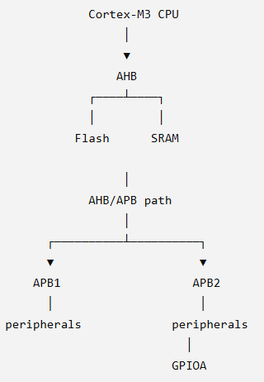
And remember:
Bus = communication pathway.
Address = identifies what we're accessing.
Data = value being transferred.
Control = type of operation.
AHB/APB = different parts of the MCU's internal bus architecture.

0.8.11 Connect it to your C code
When you write:
GPIOA_ODR |= (1 << 5);
we can conceptually expand it to:
C expression
↓
CPU instructions
↓
CPU registers + ALU
↓
Address = GPIOA_ODR
↓
Bus/interconnect
↓
GPIO peripheral
↓
ODR bit 5
↓
GPIO hardware
↓
PA5
And that is exactly the bridge we're trying to build throughout Level 0.

Quick checkpoint
Only 3 questions:
Q1
In simple terms, what is the purpose of a bus inside an MCU?
Q2
If the CPU wants to write:
0x20
to:
0x4001080C
what do these two values represent?
Q3
Why did we previously enable:
RCC_APB2ENR |= (1 << 2);
before using GPIOA?

Answers:
- it is a communication pathway for cpu and other peripherals in mcu
- 0x20 is the value to be written in the address 0x4001080c
- because, the clock for gpioa will only turn on when we enable it by using the above given line of code

Q1
A bus is a communication pathway for the CPU and other peripherals in the MCU.
Correct.
A slightly more complete version:
A bus provides the communication pathway through which addresses, data, and control information can move between the CPU, memory, and peripherals.
Q2
0x20 is the value to be written to address 0x4001080C.
Correct. ✅
So:
Address = 0x4001080C
Data = 0x00000020
Operation = WRITE
And in our STM32F103 example:
0x4001080C
↓
GPIOA_ODR
↓
bit 5 = 1
↓
PA5 output HIGH
Q3
GPIOA's clock has to be enabled using that RCC register.
Correct. ✅
RCC_APB2ENR |= (1 << 2);
means:
RCC_APB2ENR
↓
bit 2
↓
IOPAEN = 1
↓
GPIOA clock enabled
One important distinction to keep in your head:
The bus provides the communication path.
The clock provides the timing/operation of the peripheral.
They're related, but they aren't the same thing.

✅ 0.8 Buses COMPLETE
Your Level 0 status is now:
0.1 MCU fundamentals ✅
0.2 ARM ecosystem ✅
0.3 STM32 ecosystem ✅
0.4 Cortex-M3 architecture ✅
0.5 Memory ✅
0.6 Registers & bit manipulation ✅
0.7 Programmer's model ✅
0.8 Buses ✅

0.9 Clock & Reset ← NEXT
0.10 Interrupt fundamentals
0.11 Startup sequence
0.12 C → Assembly → Hardware
And 0.9 is particularly important, because we're going to connect three things you've already encountered separately:
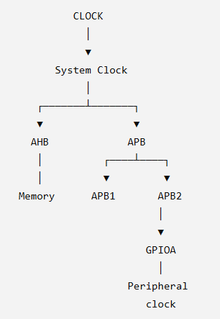
We'll take this slowly and build the STM32F103 clock tree from first principles, rather than memorizing a diagram.

